O’ZBEKISTON RESPUBLIKASI OLIY TA’LIM,FAN VA INNOVATSIYA
VAZIRLIGI
ABU RAYXON BERUNIY NOMIDAGI URGANCH DAVLAT
UNIVERSITETI

Kompyuter injineringgi fakulteti
“Kompyuter ilmlari va dasturlash texnologiyalari” yo’nalishi 234 guruh
Komilova Farangizning
“Web texnologiya ” fanidan
5-laboratoriya mashg’uloti

Qabul qildi:________________________________________________

Urganch-2026
LABORATORIYA ISHI № 5
Mavzu: MySQL da jadval yaratish va so’rov yuborish
- Laboratoriya ishining maqsadi
Ushbu laboratoriya ishining asosiy maqsadi — talabalarda MySQL ma'lumotlar bazasi bilan PHP orqali ishlash ko'nikmalarini shakllantirish. Laboratoriya davomida quyidagi bilim va ko'nikmalar egallniladi.
• MySQL ma'lumotlar bazasiga ulanish va jadval yaratish
• PHP orqali SQL so'rovlarini bajarish (CREATE, INSERT, SELECT, UPDATE, DELETE)
• Natijalarni HTML sahifada chiqarish va taqdim etish
• Xatolarni ushlash va foydalanuvchiga xabar berish
- Nazariy ma’lumotlar
  - MySQL nima?
MySQL — bu ochiq manbali (open-source) relyatsion ma'lumotlar bazasini boshqarish tizimi (RDBMS). U SQL (Structured Query Language) tilidan foydalanadi va veb-ilovalar uchun eng keng tarqalgan ma'lumotlar bazalaridan biri hisoblanadi.
  - PHP va MySQL ulanishi
PHP va MySQL o'rtasida ulanishni ta'minlash uchun ikki usul mavjud:
• MySQLi (MySQL Improved) — ob'yektga yo'naltirilgan va protsedural uslubda ishlaydi
• PDO (PHP Data Objects) — bir nechta ma'lumotlar bazalarini qo'llab-quvvatlaydi
Ushbu laboratoriya ishida MySQLi ob'yektga yo'naltirilgan usulidan foydalanamiz.
2.3. Asosiy SQL buyruqlari
Buyruq | Vazifasi | Misol
CREATE TABLE | Yangi jadval yaratish | CREATE TABLE users (id INT)
INSERT INTO | Jadvalga ma'lumot qo'shish | INSERT INTO users VALUES (1)
SELECT | Ma'lumotlarni o'qish | SELECT * FROM users
UPDATE | Ma'lumotlarni yangilash | UPDATE users SET name='Ali'
DELETE | Ma'lumotlarni o'chirish | DELETE FROM users WHERE id=1
DROP TABLE | Jadvalni o'chirish | DROP TABLE users
- Talab qilinadigan dasturlar
Laboratoriya ishini bajarish uchun quyidagi dasturlar o'rnatilgan bo'lishi kerak:
1. XAMPP yoki WAMP — Apache, MySQL va PHP ni bir vaqtda o'rnatadi
2. VS Code yoki Notepad++ — Kod yozish uchun matn muharriri
3. Brauzer (Chrome, Firefox) — Natijalarni ko'rish uchun
💡 Maslahat: XAMPP dasturini o'rnatgandan so'ng, localhost/phpmyadmin manziliga kirib MySQL ma'lumotlar bazasini boshqarish mumkin.
- Amaliy topshiriqlar
4.1. Ma’lumotlar bazasiga ulanish
Birinchi qadam — PHP da MySQL ga ulanish skriptini yozish. Quyidagi kodni config.php nomli faylga saqlang:
<?php
// Ma'lumotlar bazasi sozlamalari
$host = "localhost";
$username = "root";
$password = "";
$dbname = "mening_db";
// MySQLi ob'yektini yaratish
$conn = new mysqli($host, $username, $password);
// Ulanishni tekshirish
if ($conn->connect_error) {
die("Ulanish xatosi: " . $conn->connect_error);
}
echo "MySQL ga muvaffaqiyatli ulandi!";
?>
4.2. Ma’lumotlar bazasi va jadval yaratish
Endi ma'lumotlar bazasi va talabalar jadvalini yaratamiz:
<?php
// config.php ni ulash
require_once "config.php";
// Ma'lumotlar bazasini yaratish
$sql = "CREATE DATABASE IF NOT EXISTS mening_db";
if ($conn->query($sql)) {
echo "Ma'lumotlar bazasi yaratildi!<br>";
} else {
echo "Xato: " . $conn->error . "<br>";
}
// Ma'lumotlar bazasini tanlash
$conn->select_db("mening_db");

// Talabalar jadvalini yaratish
$sql = "CREATE TABLE IF NOT EXISTS talabalar (
id INT AUTO_INCREMENT PRIMARY KEY,
ism VARCHAR(100) NOT NULL,
familiya VARCHAR(100) NOT NULL,
yosh INT,
guruh VARCHAR(20),
email VARCHAR(150)
)";
if ($conn->query($sql)) {
echo "Jadval muvaffaqiyatli yaratildi!<br>";
} else {
echo "Jadval xatosi: " . $conn->error;
}
$conn->close();
?>
4.3. Ma’lumot qo’shish (INSERT)
Jadvalga yangi talaba ma'lumotlarini qo'shish:
<?php
require_once "config.php";
$conn->select_db("mening_db");

// Bir nechta talaba qo'shish
$talabalar = [
["Ali", "Karimov", 20, "AT-22", "ali@email.com"],
["Barno", "Rahimova", 21, "MT-21", "barno@email.com"],
["Jasur", "Toshev", 22, "AT-22", "jasur@email.com"],
["Dilnoza","Yusupova", 20, "IT-23", "dilnoza@email.com"],
];
foreach ($talabalar as $t) {
$sql = "INSERT INTO talabalar (ism, familiya, yosh, guruh, email)
VALUES ('$t[0]', '$t[1]', $t[2], '$t[3]', '$t[4]')";
if ($conn->query($sql)) {
echo "{$t[0]} {$t[1]} qo'shildi!<br>";
} else {
echo "Xato: " . $conn->error . "<br>";
}
}
$conn->close();
?>
4.4. Ma’lumotlarni o’qish (SELECT)
Jadvaldan ma'lumotlarni o'qib, HTML jadvalda ko'rsatish:
<!DOCTYPE html>
<html lang="uz">
<head>
<meta charset="UTF-8">
<title>Talabalar ro'yhati</title>
<style>
body { font-family: Arial, sans-serif; margin: 30px; }
table { border-collapse: collapse; width: 100%; }
th { background-color: #1F4E79; color: white; padding: 10px; }
td { padding: 8px 12px; border: 1px solid #ddd; }
tr:nth-child(even) { background-color: #f2f7ff; }
</style>
</head>
<body>
<h2>Talabalar ro'yhati</h2>
<?php
require_once "config.php";
$conn->select_db("mening_db");
$sql = "SELECT * FROM talabalar ORDER BY id ASC";
$result = $conn->query($sql);
if ($result->num_rows > 0) {
echo "<table>";
echo "<tr><th>#</th><th>Ism</th><th>Familiya</th>
<th>Yosh</th><th>Guruh</th><th>Email</th></tr>";
while ($row = $result->fetch_assoc()) {
echo "<tr>
<td>{$row['id']}</td>
<td>{$row['ism']}</td>
<td>{$row['familiya']}</td>
<td>{$row['yosh']}</td>
<td>{$row['guruh']}</td>
<td>{$row['email']}</td>
</tr>";
}
echo "</table>";
} else {
echo "<p>Ma'lumotlar topilmadi.</p>";
}
$conn->close();
?>
</body>
</html>
4.5. Ma’lumotni yangilash (UPDATE)
Mavjud talabaning guruhini yangilash:
<?php
require_once "config.php";
$conn->select_db("mening_db");
$id = 1;
$yangi_guruh = "IT-24";
$sql = "UPDATE talabalar SET guruh='$yangi_guruh' WHERE id=$id";
if ($conn->query($sql)) {
if ($conn->affected_rows > 0) {
echo "Ma'lumot muvaffaqiyatli yangilandi!";
} else {
echo "Bunday ID topilmadi.";
}
} else {
echo "Xato: " . $conn->error;
}
$conn->close();
?>

4.6. Ma’lumotni o’chirish (DELETE)
Berilgan ID bo'yicha talabani o'chirish:
<?php
require_once "config.php";
$conn->select_db("mening_db");
$id = 3; // O'chiriladigan talabaning ID si
$sql = "DELETE FROM talabalar WHERE id=$id";
if ($conn->query($sql)) {
if ($conn->affected_rows > 0) {
echo "ID=$id bo'lgan talaba o'chirildi!";
} else {
echo "Bunday talaba topilmadi.";
}
} else {
echo "Xato: " . $conn->error;
}
$conn->close();
?>
- Mustaqil topshiriqlar
Laboratoriya ishini tugatgandan so'ng, quyidagi vazifalarni mustaqil bajaring:
1. Yangi ma'lumotlar bazasi va kamida 4 ta ustunli jadval yarating. Jadval mavzusini o'zingiz tanlang (kitoblar, mahsulotlar, filmlar va h.k.).
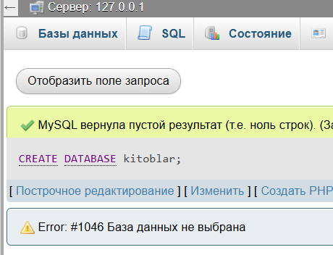
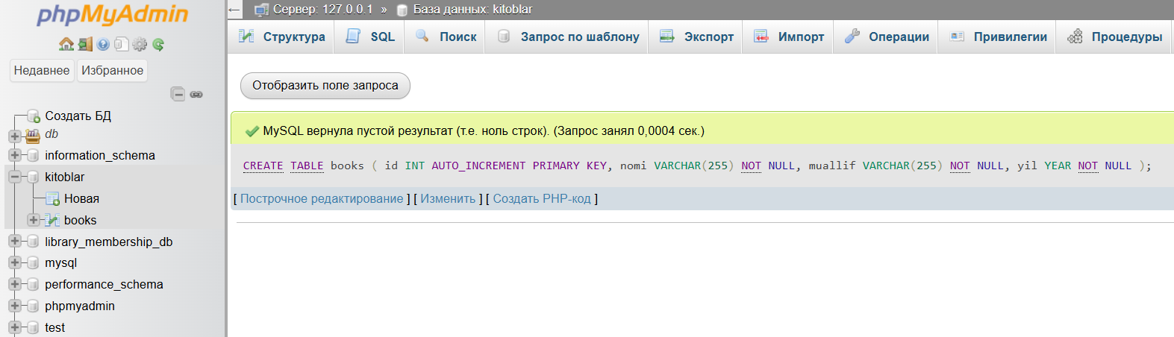
2. Yaratilgan jadvalga kamida 5 ta yozuv qo'shing (INSERT).
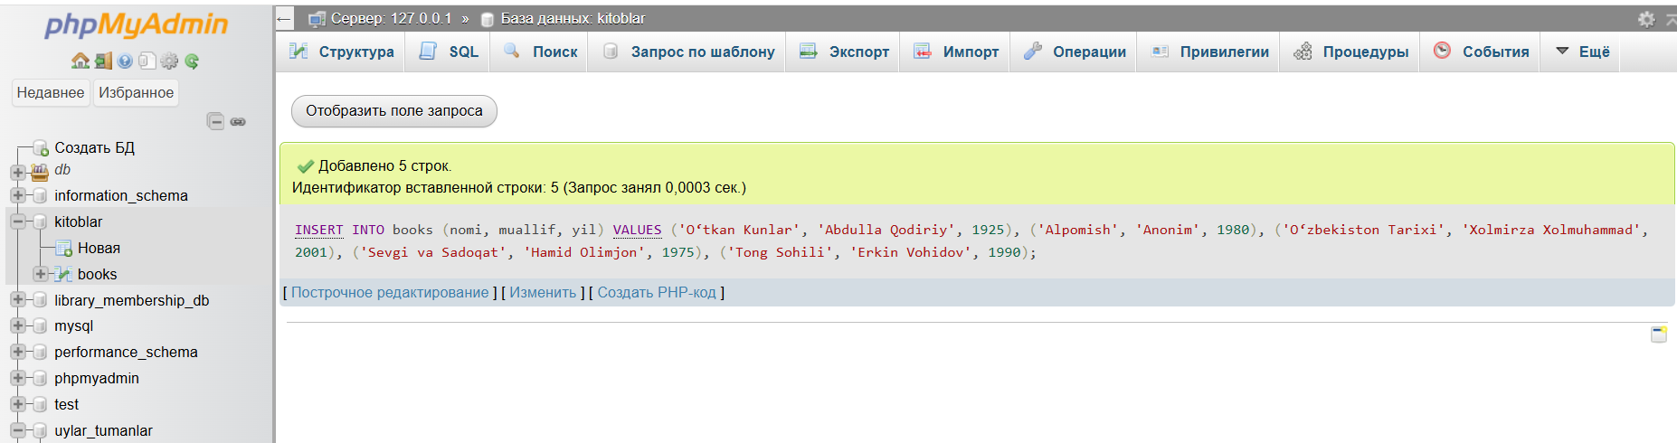
3. SELECT so'rovi bilan barcha ma'lumotlarni HTML jadval ko'rinishida chiqaring.
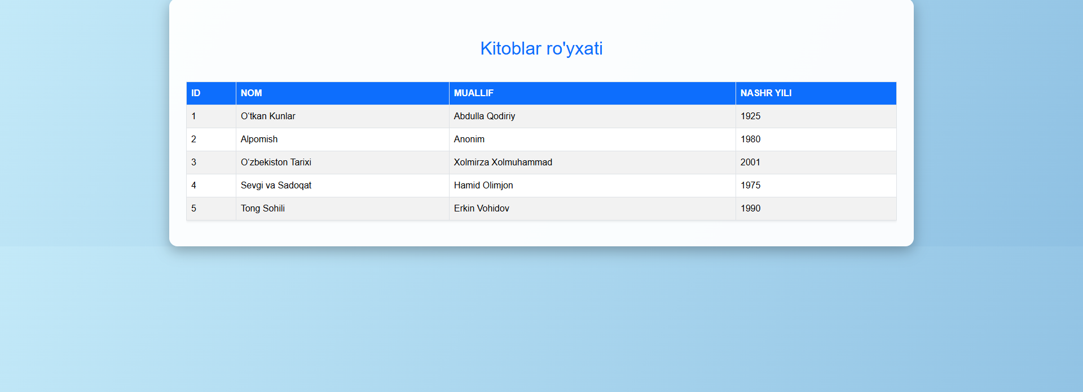
4. WHERE shartidan foydalanib, ma'lum bir ustun qiymati bo'yicha filtrlab ko'rsating.
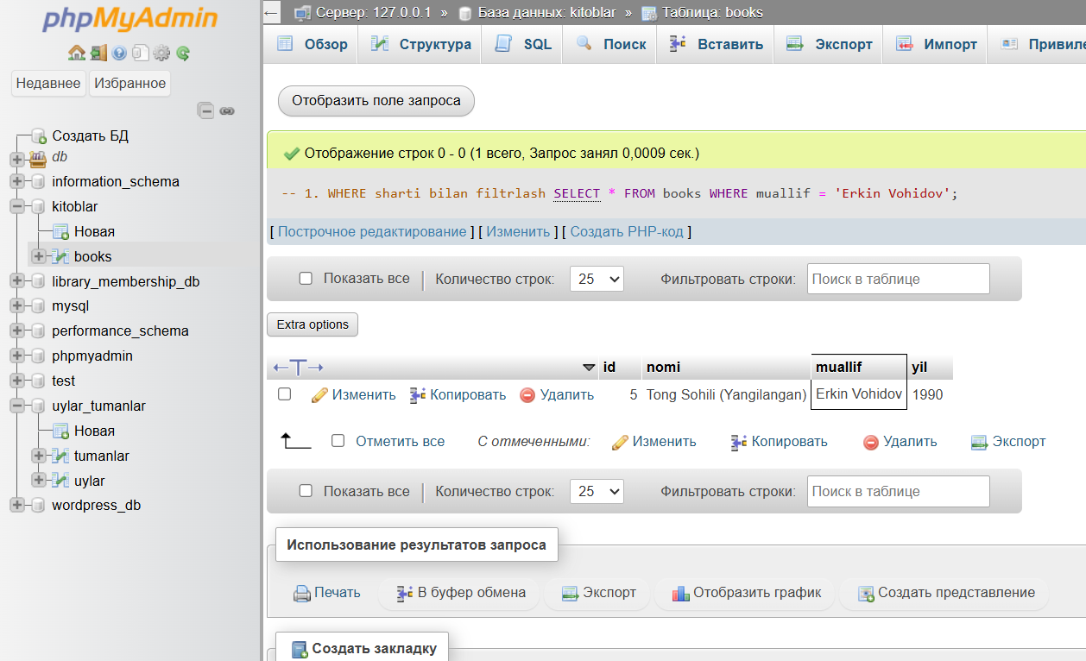
5. Bitta yozuvni yangilang (UPDATE) va natijani tekshiring.
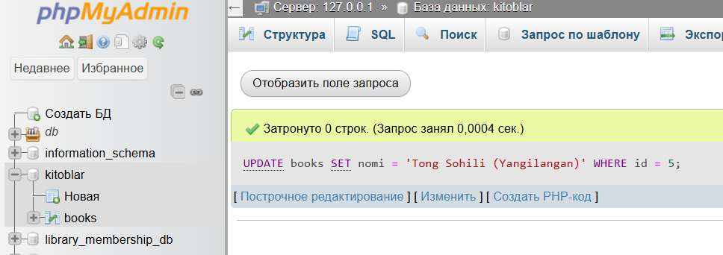
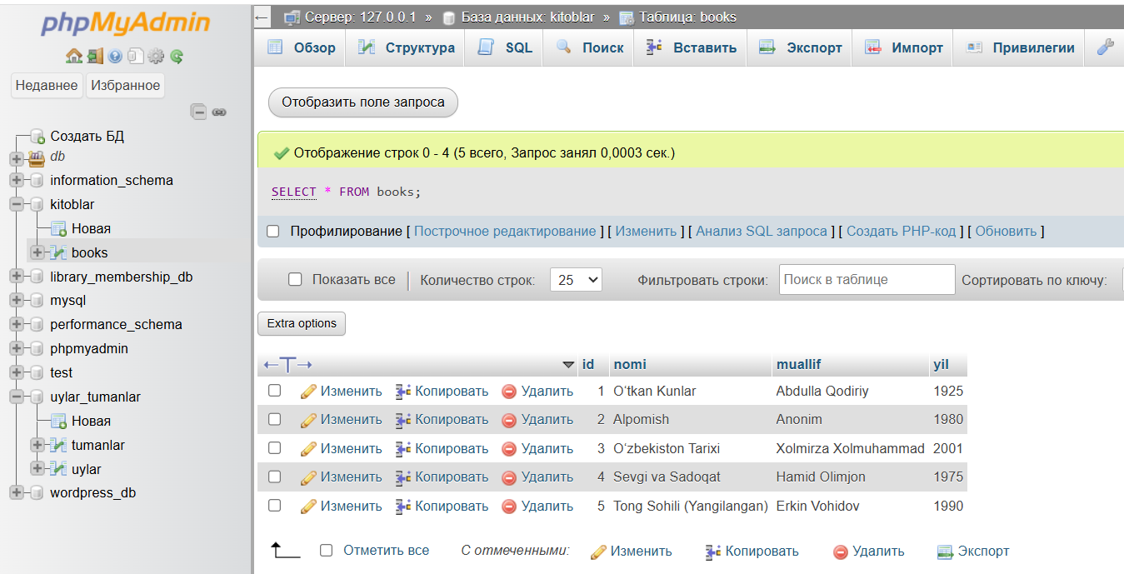
6. HTML formasi orqali foydalanuvchi ma'lumot kiritib, bazaga qo'sha oladigan sahifa yarating.
Kodi
<?php
// 1. Databasega ulanish
$host = "localhost";
$user = "root";
$password = "";
$dbname = "kitoblar";

$conn = new mysqli($host, $user, $password, $dbname);
if ($conn->connect_error) {
die("Ulanishda xatolik: " . $conn->connect_error);
}

// 2. Formadan ma'lumot kelganini tekshirish va INSERT qilish
if ($_SERVER['REQUEST_METHOD'] == 'POST') {
$nomi = $conn->real_escape_string($_POST['nomi']);
$muallif = $conn->real_escape_string($_POST['muallif']);
$yil = intval($_POST['yil']);

$sql_insert = "INSERT INTO books (nomi, muallif, yil) VALUES ('$nomi', '$muallif', $yil)";

if ($conn->query($sql_insert) === TRUE) {
$message = "Kitob muvaffaqiyatli qo'shildi!";
} else {
$message = "Xatolik: " . $conn->error;
}
}

// 3. Hozirgi barcha kitoblarni olish
$sql_select = "SELECT * FROM books ORDER BY id ASC";
$result = $conn->query($sql_select);
?>

<!DOCTYPE html>
<html lang="uz">
<head>
<meta charset="UTF-8">
<meta name="viewport" content="width=device-width, initial-scale=1.0">
<title>Kitob qo'shish va ro'yxat</title>
<!-- Bootstrap CSS -->
<link href="https://cdn.jsdelivr.net/npm/bootstrap@5.3.2/dist/css/bootstrap.min.css" rel="stylesheet">
<style>
body {
background: linear-gradient(120deg, #d4fc79, #96e6a1);
font-family: Arial, sans-serif;
}
h2 {
text-align: center;
margin: 30px 0;
color: #2c3e50;
}
.container {
background-color: rgba(255,255,255,0.95);
padding: 30px;
border-radius: 15px;
box-shadow: 0 8px 25px rgba(0,0,0,0.3);
}
.table thead th { background-color: #2c3e50; color: #fff; text-transform: uppercase; }
.table-striped>tbody>tr:nth-of-type(odd) { background-color: #e0f7fa; }
.table-striped>tbody>tr:nth-of-type(even) { background-color: #b2ebf2; }
.table-hover tbody tr:hover { background-color: #4dd0e1; font-weight:bold; color:#000; }
</style>
</head>
<body>

<div class="container">
<h2>Kitob qo'shish</h2>

<?php if(isset($message)) echo "<p class='text-center text-success fw-bold'>$message</p>"; ?>

<!-- HTML forma -->
<form method="POST" class="mb-4">
<div class="mb-3">
<label class="form-label">Kitob nomi:</label>
<input type="text" name="nomi" class="form-control" required>
</div>
<div class="mb-3">
<label class="form-label">Muallif:</label>
<input type="text" name="muallif" class="form-control" required>
</div>
<div class="mb-3">
<label class="form-label">Nashr yili:</label>
<input type="number" name="yil" class="form-control" required min="1000" max="<?php echo date("Y"); ?>">
</div>
<button type="submit" class="btn btn-success w-100">Kitob qo'shish</button>
</form>

<h2>Kitoblar ro'yxati</h2>

<!-- Jadval -->
<div class="table-responsive">
<table class="table table-bordered table-striped table-hover shadow-sm">
<thead>
<tr>
<th>ID</th>
<th>Nom</th>
<th>Muallif</th>
<th>Nashr yili</th>
</tr>
</thead>
<tbody>
<?php if ($result->num_rows > 0): ?>
<?php while($row = $result->fetch_assoc()): ?>
<tr>
<td><?php echo $row['id']; ?></td>
<td><?php echo $row['nomi']; ?></td>
<td><?php echo $row['muallif']; ?></td>
<td><?php echo $row['yil']; ?></td>
</tr>
<?php endwhile; ?>
<?php else: ?>
<tr><td colspan="4" class="text-center">Ma'lumot topilmadi</td></tr>
<?php endif; ?>
</tbody>
</table>
</div>
</div>

<script src="https://cdn.jsdelivr.net/npm/bootstrap@5.3.2/dist/js/bootstrap.bundle.min.js"></script>
</body>
</html>

<?php
$conn->close();
?>
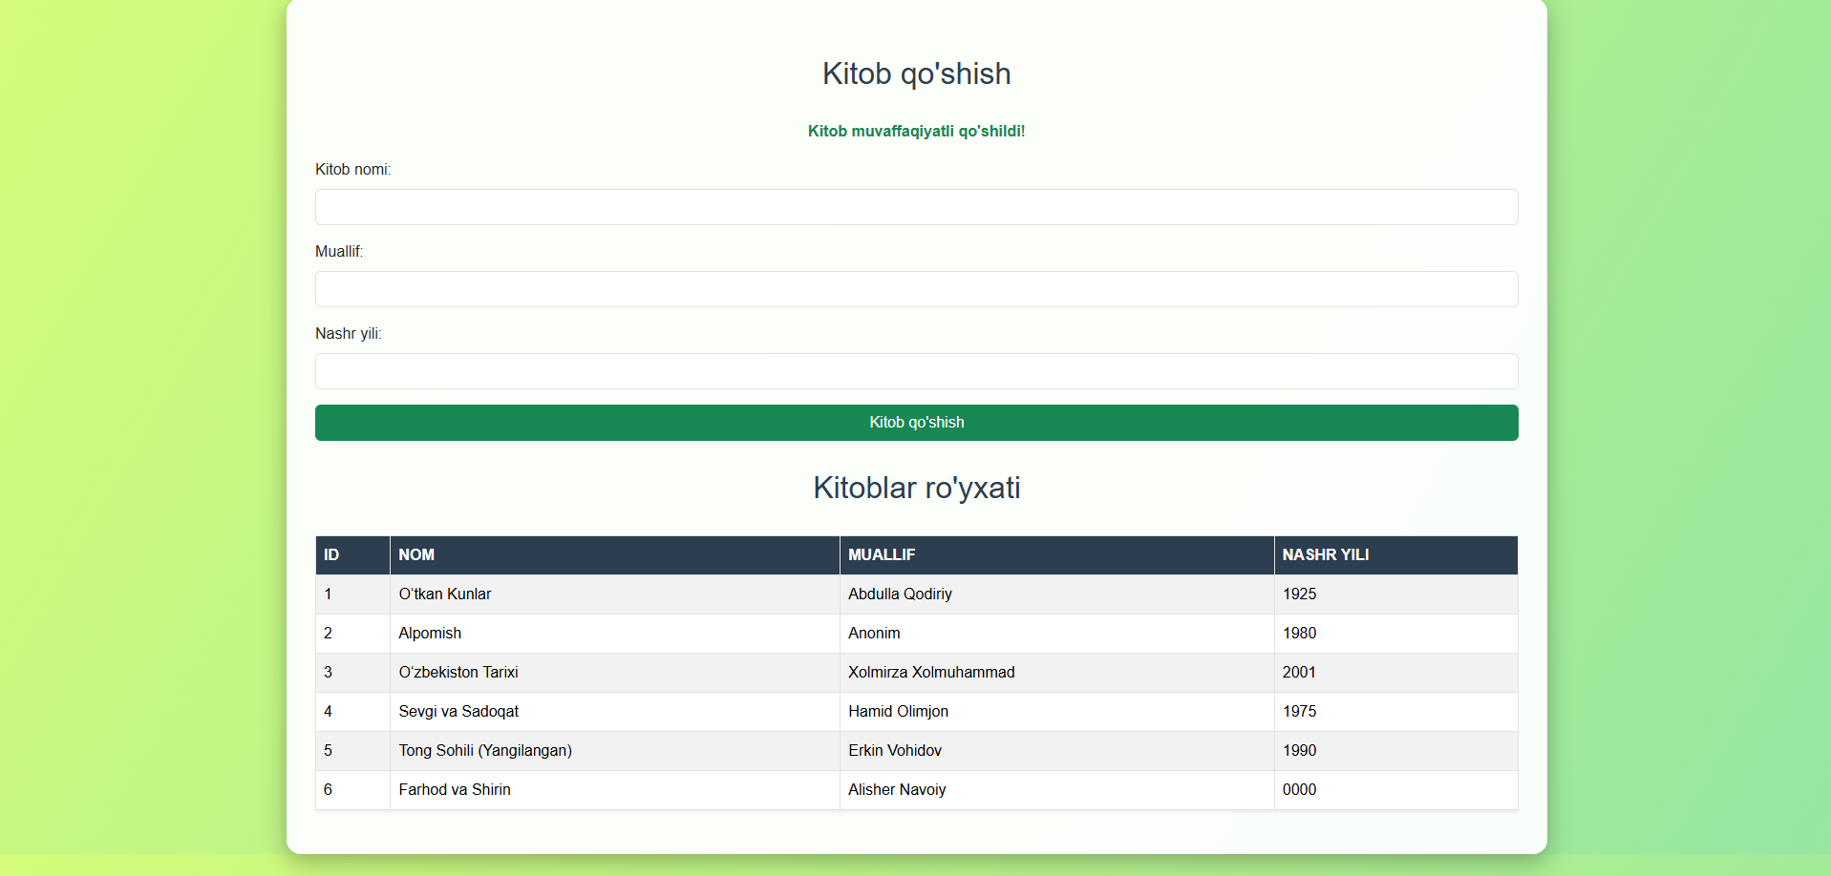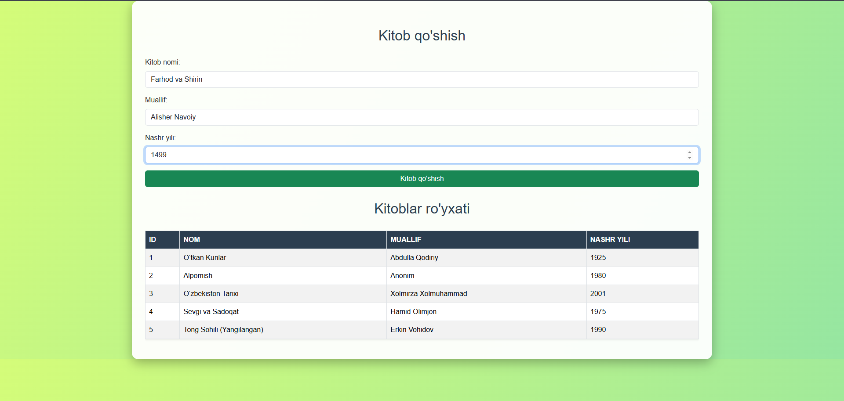
6. Nazorat savollari
1. MySQLi va PDO o'rtasidagi farq nima?
MySQLi faqat MySQL bilan ishlaydi, PDO esa ko‘p turdagi ma’lumotlar bazasi (MySQL, SQLite, PostgreSQL) bilan ishlay oladi. PDO prepared statements bilan xavfsiz va platforma mustaqil.
2. PHP da MySQLi ob'yektini qanday yaratasiz va ulanishni qanday tekshirasiz?
$conn = new mysqli("localhost", "root", "", "database_name");
if ($conn->connect_error) {
die("Ulanishda xatolik: " . $conn->connect_error);
}
3. AUTO_INCREMENT kalit so'zi qanday ishlaydi?
Jadval ustunidagi har yangi yozuv avtomatik raqamlanadi va takrorlanmaydi. Asosan PRIMARY KEY bilan ishlatiladi.
4. SQL da PRIMARY KEY va FOREIGN KEY farqi nimada?
PRIMARY KEY – jadvaldagi har bir satrni noyob aniqlaydi.
FOREIGN KEY – boshqa jadvaldagi PRIMARY KEY bilan bog‘lanadi, relatsiya yaratadi.
5. $result->fetch_assoc() va $result->fetch_row() farqi nima?
fetch_assoc() – natijani assotsiativ massiv sifatida beradi ($row['column_name']).
fetch_row() – natijani indeksli massiv sifatida beradi ($row[0]).
6. SQL in'ektsiyalaridan qanday himoyalanish mumkin?
Prepared statements va parameter binding ishlatish. Foydalanuvchi kiritgan ma’lumotlarni tozalash (mysqli_real_escape_string).
7. $conn->affected_rows xususiyati nima uchun ishlatiladi?
So‘nggi INSERT, UPDATE, DELETE amallari bilan nechta satr o‘zgarganini ko‘rsatadi.
7. Baholash mezonlari
№ | Mezon | Ball | Baho
1 | MySQL ga PHP orqali ulanish amalga oshirilgan | 10
2 | Ma'lumotlar bazasi va jadval yaratilgan (CREATE) | 15
3 | Jadvaldga ma'lumotlar qo'shilgan (INSERT) | 15
4 | Ma'lumotlar to'g'ri o'qilib, HTML da ko'rsatilgan (SELECT) | 20
5 | Yangilash (UPDATE) va o'chirish (DELETE) ishlagan | 15
6 | Mustaqil jadval va qo'shimcha funksionallik | 15
7 | Kod tartibliligi va izohlari | 10
JAMI: |  | 100
Topshiriqlar
10-topshiriq. Uylar va tumanlar
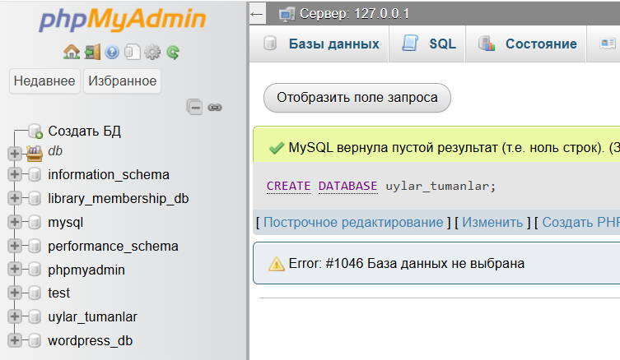
1-jadval (ustunlar)
tumanlar — id, nomi, shahar
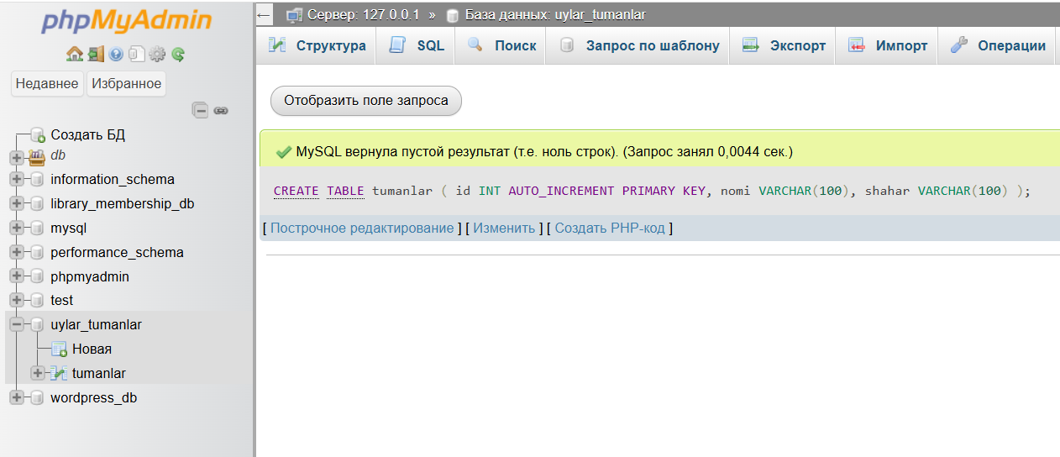
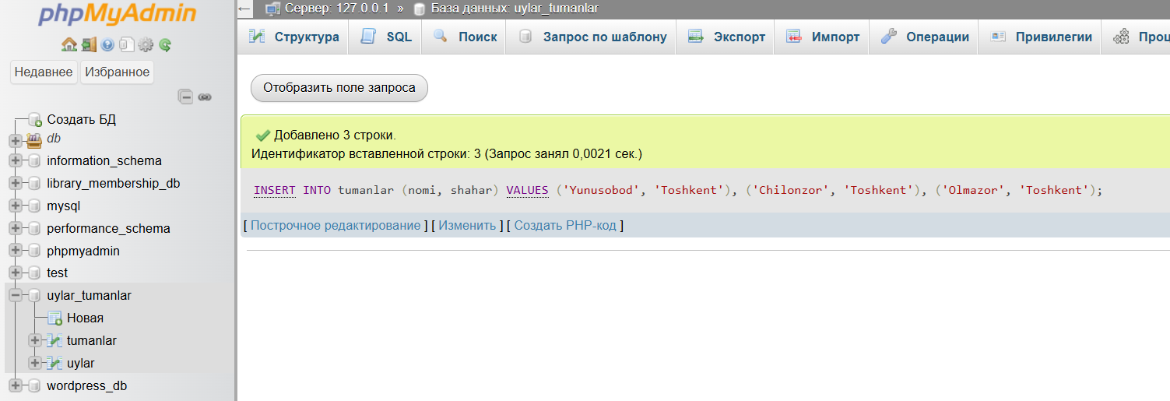
2-jadval (ustunlar)
uylar — id, xonalar, maydon, narx, tuman_id
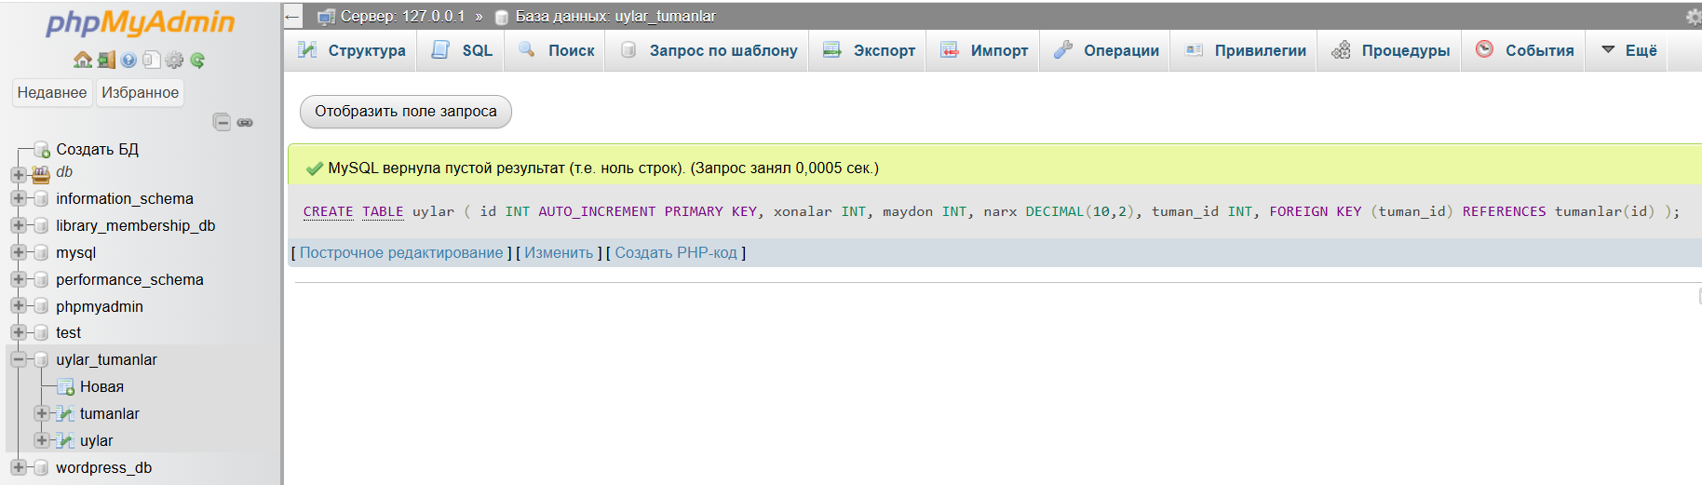
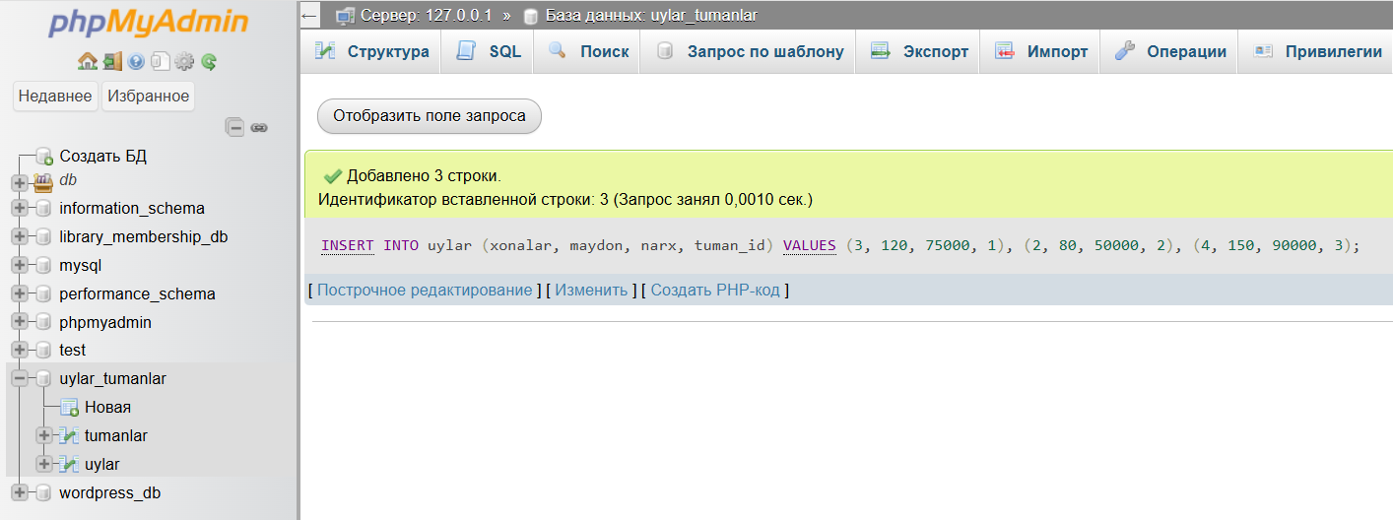
Php kodi
<?php
// 1. Databasega ulanish
$host = "localhost";
$user = "root";
$password = "";
$dbname = "uylar_tumanlar";
$conn = mysqli_connect($host, $user, $password, $dbname);
if (!$conn) {
die("Ulanishda xatolik: " . mysqli_connect_error());
}
// 2. Ma'lumotlarni olish
$sql = "SELECT uylar.id, uylar.xonalar, uylar.maydon, uylar.narx,
tumanlar.nomi AS tuman_nomi, tumanlar.shahar
FROM uylar
JOIN tumanlar ON uylar.tuman_id = tumanlar.id";

$result = mysqli_query($conn, $sql);
?>
<!DOCTYPE html>
<html lang="uz">
<head>
<meta charset="UTF-8">
<meta name="viewport" content="width=device-width, initial-scale=1.0">
<title>Uylar va Tumanlar</title>
<!-- Bootstrap CSS -->
<link href="https://cdn.jsdelivr.net/npm/bootstrap@5.3.2/dist/css/bootstrap.min.css" rel="stylesheet">
<style>
body {
background: linear-gradient(120deg, #ffe259, #ffa751);
font-family: 'Arial', sans-serif;
}
h2 {
color: #0d6efd; /* Yorqin ko‘k rang */
text-shadow: 2px 2px #ffffff; /* oq shadow fon bilan ajratish uchun */
font-size: 3rem;
text-align: center;
margin-bottom: 40px;
}
.table thead th {
background-color: #ff6f61;
color: #fff;
text-transform: uppercase;
letter-spacing: 1px;
}
.table-striped>tbody>tr:nth-of-type(odd) {
background-color: #fff7e6;
}
.table-striped>tbody>tr:nth-of-type(even) {
background-color: #ffd9b3;
}
.table-hover tbody tr:hover {
background-color: #ffcc80;
color: #000;
font-weight: bold;
}
.container {
background-color: rgba(255, 255, 255, 0.9);
padding: 30px;
border-radius: 15px;
box-shadow: 0 8px 25px rgba(0,0,0,0.3);
}
</style>
</head>
<body>
<div class="container my-5">
<h2>Uylar va Tumanlar</h2>
<div class="table-responsive">
<table class="table table-striped table-hover table-bordered shadow-sm">
<thead>
<tr>
<th>ID</th>
<th>Xonalar</th>
<th>Maydon (m²)</th>
<th>Narx (USD)</th>
<th>Tuman</th>
<th>Shahar</th>
</tr>
</thead>
<tbody>
<?php if(mysqli_num_rows($result) > 0): ?>
<?php while ($row = mysqli_fetch_assoc($result)): ?>
<tr>
<td><?php echo $row['id']; ?></td>
<td><?php echo $row['xonalar']; ?></td>
<td><?php echo $row['maydon']; ?></td>
<td><?php echo number_format($row['narx'], 2); ?></td>
<td><?php echo $row['tuman_nomi']; ?></td>
<td><?php echo $row['shahar']; ?></td>
</tr>
<?php endwhile; ?>
<?php else: ?>
<tr>
<td colspan="6" class="text-center">Ma'lumot topilmadi</td>
</tr>
<?php endif; ?>
</tbody>
</table>
</div>
</div>
<!-- Bootstrap JS (optional) -->
<script src="https://cdn.jsdelivr.net/npm/bootstrap@5.3.2/dist/js/bootstrap.bundle.min.js"></script>
</body>
</html>
<?php
mysqli_close($conn);
?>
Natijasi
